READ ME Instructions on how to set up the tool, import the project and execute the test

- Download Eclipse IDE https://www.eclipse.org/
- Install Java and add it in the environment variable https://thoughtcoders.com/blog/install-java-and-setup-environment-variable/
- Maven Installation
  - Open Eclipse
  - Go to Help -> Eclipse Marketplace
  - Search by Maven
  - Click "Install" button at "Maven Integration for Eclipse" section
  - Follow the instruction step by step
- TestNG installation
  - Open Eclipse
  - Go to Help -> Eclipse Marketplace
  - Search by TestNG
  - Click "Install" button at “TestNG for Eclipse" section
  - Follow the instruction step by step
- Code import
  - Eclipse -> File -> Import
  - Under the Maven Category -> Click Existing Maven projects
  - Browse the folder where the unzipped folder exists and select the main folder “MovieDBRESTTestEngine”
  - Select the pom.xml

- Test Execution :
  - Under the project Explorer, find the testNG.xml -> right click ->run as TestNGSuite
- Reports :
  - Under the project Explorer-> right click on the test-output folder -> click on Refresh
  - Rightclick and open the “Test 1 stem TestExecutionReport.html” / “Test 2 avatar TestExecutionReport.html” in any browser like chrome / internet explorer

Test Console Output Sample pic:

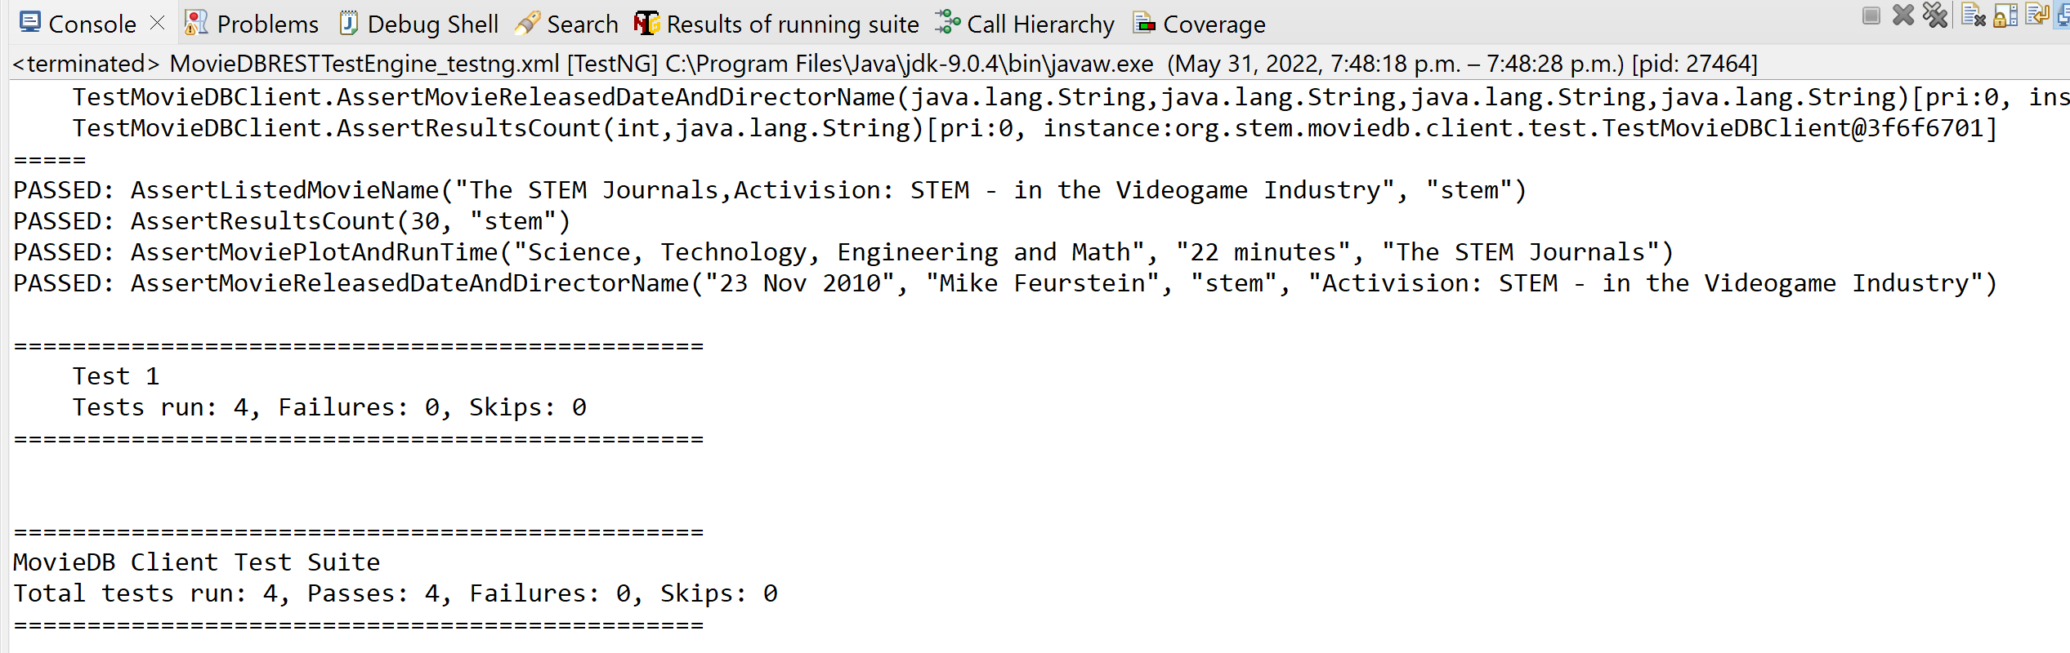

Extent Report for test execution:
